Assignment #1

Artificial Intelligence CSCE 523

Due: 8:00 AM, Wednesday January 16, 2019

Agents and Uninformed Search

Marvin Newlin

* 1. The philosophical view of intelligence is the most correct view of intelligence to me. While the physicalist view provides some good points, i.e. that everything is physical, the philosophical viewpoint seems to be the most comprehensive. While difficult to pinpoint, qualia do seem to play a role in intelligence itself.
  2. I do not believe that an artificial intelligence is capable from the philosophical viewpoint because in general, machines to me are not capable of experiencing qualia, i.e. knowing what is like to enjoy food or visit a wonder of the world. These kinds of things are not possible for machines but yet do have a part in intelligence.
  3. The Lady Lovelace objection seems to still carry some weight. Even today, the argument can be made that computers only do what they are programmed to do. Turing’s refutation of this objection is based on the interpretation of the question as “machines can never surprise us.” Based on this interpretation, the refutation is valid since it is based in human nature. The argument from consciousness still carries much weight today, and is somewhat the basis of the philosophical view of intelligence. The refutation is valid based on the test he proposes since the argument from consciousness does invalidate the test as he claims.
  4. There are no new objections that I can think of. Turing was incredibly far ahead of his time in thinking about these subjects
  5. The Turing Test as proposed is a useful benchmark for computers. The problem in structuring a “better” test that refutes the argument from consciousness is that to refute the argument, for example the composition of a sonnet from “thoughts & emotions not fall of symbols”, one would have to be able to see the process by which the sonnet is produced, which defeats the whole purpose of the test.

1. The existence of intractable problems doesn’t necessarily imply that strong AI is impossible. As humans, we deal with intractable problems through methods like approximation, comparison, etc without directly solving these intractable problems. Thus, if AI develops to the point that it can deal with these intractable problems in the same manner, then strong AI should be possible.
   1. No, a simple reflex agent would not perform perfectly rationally in this instance. Since it doesn’t know what its environment is it is not possible to expect the simple reflex agent to maximize its performance measure and thus act rationally (p. 38, textbook). If it doesn’t know, for example, dirt locations, and it continues to operate without finding dirt and the performance measure is dirt cleaned then it would not be acting rationally.
   2. An environment in which a random agent would need to repeatedly perform the same sequence of actions would be an environment in which it performs poorly since the random agent chooses a random sequence of actions so it would not regularly choose a repeated set of actions.
   3. Yes, a reflex agent with state can outperform a simple reflex agent. Consider the case of the robotic vacuum cleaner. In the simple case, if it bumps into an object it reverses but its rules also tell it to move forward if the space is clean. Since the space is clean it will move forward into the wall again and then be stuck in a continual cycle. However, with state, the agent would know that it just bumped into an obstacle and adjust, i.e. rotate, before resuming action according to its rules.

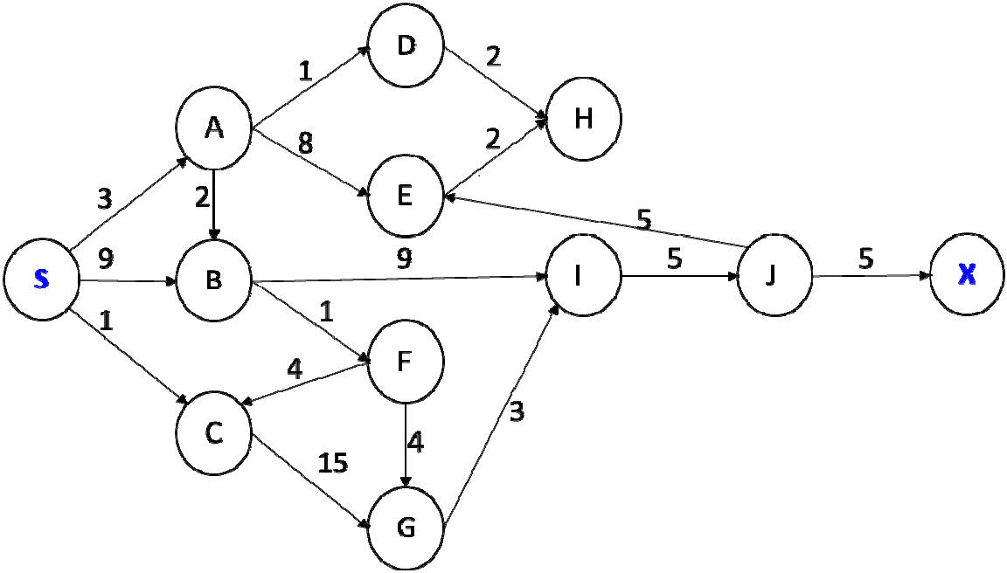

* 1. BFS



* 1. DFS

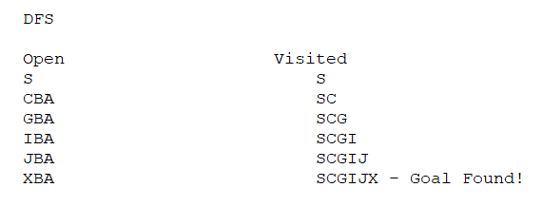

* 1. UCS

